**MOODIFY (Spotify Add-on)**

***A Minor Project Report submitted to the***

**RAJIV GANDHI PROUDYOGIKI VISHWAVIDYALAYA, BHOPAL**

***in partial fulfillment of the requirements for the award of the degree of***

**BACHELOR OF TECHNOLOGY**

**IN**

**COMPUTER SCIENCE & BUSINESS SYSTEM**

***Submitted by***

**Amit Singh Chauhan (0105CB201005)**

**Gagan Wagadre (0105CB201016)**

**Pranjal Mishra (0105CB201038)**

***Under the Guidance of***

**Prof. Princy Shrivastava**



**DEPARTMENT**

**OF**

**COMPUTER SCIENCE & BUSINESS SYSTEM**

**ORIENTAL INSTITUTE OF SCIENCE & TECHNOLOGY**

**BHOPAL (M.P.) - 462022, INDIA**

**Jul-Dec 2022**

|  |  |
| --- | --- |
|  | Phone: 0755 – 2759026, 2529057,  Fax: 0755 - 2529472  E-mail: [oistbpl@oriental.ac.in](mailto:oistbpl@oriental.ac.in)  website: [www.oriental.ac.in](http://www.oriental.ac.in) |

**ORIENTAL INSTITUTE OF SCIENCE & TECHNOLOGY**

Approved by AICTE, New Delhi & Govt. of M.P. Affiliated to Rajiv Gandhi Proudyogiki Vishwavidyalaya, Bhopal

Oriental Campus, Opp. Patel Nagar, Raisen Road, Bhopal-462 022 (M.P.) INDIA

**DEPARTMENT OF COMPUTER SCIENCE & BUSINESS SYSTEM**

**CERTIFICATE**

This is to certify that the project entitled **MOODIFY** being submitted by **Amit Singh Chauhan, Gagan Wagadre, and Pranjal Mishra** student(s) of V Semester, B.Tech. in Computer Science & Business System have done their work as MINOR PROJECT for Partial fulfillment of the B.Tech degree from RGPV, Bhopal (M.P.) is a record of bonafide work carried out by them under our supervision.

Date: 05/2022

Place: BHOPAL

|  |  |
| --- | --- |
| Prof. Princy Shrivastava | **Prof. Atul Barve** |
| SUPERVISOR & ASSISTANT PROFESSOR | HEAD OF THE DEPARTMENT |
| Department of Computer Science & Business System | Department of Computer Science & Business System |
| Oriental Institute of Science & Technology | Oriental Institute of Science & Technology |

**ACKNOWLEDGEMENT**

We take the opportunity to express our cordial gratitude and deep sense of indebtedness to our guide **Prof. Princy Shrivastava**, Department of **Computer Science & Business System**, Oriental Institute of Science and Technology for the valuable guidance and inspiration throughout the project duration. We feel thankful to him for his innovative ideas, which led to successful submission of this minor project work. We feel proud and fortunate to work under such an outstanding mentor. He had always welcomed our problems and helped us to clear our doubts. We will always be grateful to him for providing me moral support and sufficient time.

We sincerely thank **Prof. Atul Barve, Head of Department**, Computer Science & Business System, Oriental Institute of Science and Technology Bhopal for providing me with moral support and guidance during the project work in the Department.

We wish to express our deep gratitude to **Dr. Rajesh. K. Shukla, Director,** Oriental Institute of Science and Technology Bhopal for his kind permission to carry out the work at OIST Bhopal.

Finally we would like to thank our Institution, all the faculty members and supporting staff who directly or indirectly helped us in carrying out this project work.

We also extend our heartfelt thanks to our families and well-wishers.

**Amit Singh Chauhan (0105CB201005)**

**Gagan Wagadre (0105CB201016)**

**Pranjal Mishra (0105CB201038)**

**ABSTRACT**

*This project is about the web music player application development using Android. The biggest difference between the music player and existing applications is that it is completely free for users to use. It will integrate the advantages of existing music players on the market, as far as possible to mining out the existing music players' function, and then do the filtering in order to eliminate function that not practical or low cost-effective. Also, it will be keep improved based on user feedback.*

*In addition, depending on the user's usage scenario, the music player will also add some modes, such as Around you and new Discover page, to allow users to use the application in any situation or environment. Moreover, the music player will have audio trim features, allowing users to trim the best part of their favorite song into phone ringtone or alarm. On the other hand, the existing music players pay less attention to the control of gestures. Therefore, the music player will solve the limitation by adding more gestures and shake the phone feature for media control to make it more user-friendly and humanity.*

*In a nutshell, the methodology for developing the web music application used in this project is the agile development cycle. The agile development cycle consists of six phases, which is requirements analysis, planning, design, implementation or development, testing, and deployment. Due to the iterative and flexible nature of this approach, it is able to effectively adapt to users with changing requirements.*

**TABLE OF CONTENTS**

|  |  |
| --- | --- |
| *Bonafide Certificate…………………………………………………………………...........* | *i* |
| *Acknowledgements …………………………………………………………………...........* | *ii* |
| *Abstract …………………………………………………………………………………….* | *iii* |
| *Table of Contents …………………………………………………………………………..* | *iv* |
| *List of Figures ………………………………………………………………………………* | *vi* |
| *List of Tables ……………………………………………………………………………….* | *vii* |
| *List of Abbreviations………………………………………………………………………..* | *ix* |

|  |  |  |
| --- | --- | --- |
| ***1.*** | ***introduction……………………………………………………*** | ***1*** |
| *1.1* | *Objective* | *1* |
| *1.2* | *Scope* |  |
| *1.3* | *Problem identification* |  |
| *1.4* | *Methodology* |  |
| ***2.*** | ***BACKGROUND AND LITERATURE SURVEY…………………*** |  |
| *2.1* | *Existing system* |  |
| *2.2* | *Software Requirement Specifications* |  |
| *2.3* | *Feasibility Study* |  |
| *2.4* | *Innovativeness and Usefulness* |  |
| *2.5* | *Modification and improvement over the existing implementation* |  |
| ***3.*** | ***PROCESS MODEL….……………………………………………….*** |  |
| *3.1* | *Software Process Model Used* |  |
| *3.2* | *Proposed Project Model* |  |
| *3.3* | *Market Potential and Competitive Advantage* |  |
| *3.4* | *Project Estimation* |  |
| *3.5* | *Project Schedule* |  |
| ***4.*** | ***DESIGN………………………………………………..………………*** |  |
| *4.1* | *Algorithm* |  |
| *4.2* | *Data Flow Diagram* |  |
| *4.3* | *Entity Relationship Diagram* |  |
| *4.4* | *USE-CASE diagrams* |  |
| *4.5* | *Class Diagram* |  |
| *4.6* | *Activity Diagram* |  |
| *4.7* | *Sequence Diagram* |  |
| ***5.*** | ***TECHNOLOGY AND TOOLS USED………………………………*** |  |
| *5.1* | *Technology Used* |  |
| *5.2* | *Front-end Tools* |  |
| *5.3* | *Back-end Tools* |  |
| *5.4* | *Operating System* |  |
| ***6.*** | ***HARDWARE REQUIREMENT…………………………………….*** |  |
| *6.1* | *System Specification (Server Side)* |  |
| *6.2* | *System Specification (Client Side)* |  |
| ***7.*** | ***CODING………………………………………………………………*** |  |
| ***8.*** | ***TESTING …..…………………………………………………………*** |  |
| *8.1* | *Testing Method Used* |  |
| *8.2* | *Test cases with results* |  |
| ***9.*** | ***Screen Layouts…………………………………………………………*** |  |
| ***10.*** | ***Future Enhancement…………………………………………………*** |  |
| ***11.*** | ***Conclusion ……………………………………………………………*** |  |
| ***12.*** | ***Bibliography …………………………………………………………..*** |  |

**LIST OF FIGURES**

|  |  |  |
| --- | --- | --- |
| ***Figure No.*** | ***Title*** |  |
| *1.1* | *Agile Development Cycle* |  |
| *2.1* | *Spotify Discover page UI* |  |
| *2.2* | *Spotify Song player UI* |  |
| *2.3* | *Saavan ui* |  |
| *3.1* | *Use case diagram of Moodify* |  |
| *3.2* | *Activity Diagram for User to Listen to Music* |  |
| *3.3* | *ER Digram for User to Listen to Music* |  |
| *3.4* | *System Model Diagram for User to Listen to Music* |  |
| *3.5* | *Data Flow Diagram for User to Listen to Music* |  |
| *3.6* | *Algorithm for User to Listen to Music* |  |
| *9.1* | *UI on Desktop* |  |
| *9.2* | *UI on Tablet* |  |
| 9.3 | *UI on Mobile* |  |
|  |  |  |
|  |  |  |
|  |  |  |
|  |  |  |
|  |  |  |

**LIST OF TABLES**

|  |  |  |
| --- | --- | --- |
| ***Table No.*** | ***Title*** |  |
| *2.1* | *STRENGTH AND WEAKNESS OF REVIEWED APPLICATION* |  |
| *3.1* | *USE CASE DESCRIPTION OF LISTEN TO MUSIC* |  |
| *3.2* | *USE CASE DESCRIPTION OF PROGRESS BAR* |  |
| *3.3* | *USE CASE DESCRIPTION OF SEARCH MUSIC ONLINE* |  |
| *8.1* | *UNIT TESTING OF MUSIC PLAYER MODULE* |  |
| *8.2* | *UNIT TESTING OF MEDIA ICON BUTTON PLAYBACK CONTROL MODULE* |  |
| *8.3* | *UNIT TESTING OF DRIVER MODE MODULE* |  |
| *8.4* | *UNIT TESTING OF AROUND YOU MODULE* |  |
|  |  |  |
|  |  |  |

**LIST OF ABBREVIATIONS**

|  |  |
| --- | --- |
| ***ABBREVIATION*** | ***DESCRIPTION*** |
| *CPU* | *Central Processing Unit* |
| *IOS* | *iPhone Operating System* |
| *MV* | *Music Video* |
| *MP3* | *MPEG 1 Audio Layer 3* |
| *MP4* | *MPEG LAYER 4* |
| *UI* | *User interface* |
| *VIP* | *Very Important Person* |
| *XML* | *Full extensible markup language* |
| *APK* | *Android Application Package* |
|  |  |

**Chapter 1 INTRODUCTION**

**1.1 Objectives**

The objective of this thesis is to propose development of android that:

1. **Make it with a simple feature and run smoothly**

By using this mp3 music player will make users feel comfortable and relaxed because it will pay more attention to the features commonly used by users, excluding some rarely used features that occupy a large of system processors, making the music player lightweight, simple, but also has powerful basic features.

1. **Support gesture control**

The MP3 music player will add features triggered by gestures to make it easier for users to use as well as less dependent on touch buttons. For example, a user can skip next or previous songs by simply swiping left and right on the anywhere of the screen in the playing interface.

1. **Support quick search**

The lack of a search bar in the music list is unacceptable. Therefore, the mp3 music player will use the search bar as well as fast scroll using alphabets on the right side of the screen, allowing users to quickly filter through hundreds of songs to find the ones users want to play.

**1.2 Scope**

In modern society, people live a fast-paced life, and pressure is constantly present in lives. Due to the wide use of mobile phones, music has become the daily essential spiritual food, everyone's mobile phone inside there must be a music player. An application like web music players is used to balance stress and happiness. It accompanies people anytime, anywhere and anyplace such as when people taking the bus and exercising. The mobile MP3 music player application is designed to allow users to listen to music in a more convenient and comfortable way without too much restriction. Moreover, it can play the music properly without interference from advertisements and offline. Since many developers realize that modern urbanites are living in a stressful situation, they have captured the commercial opportunity, therefore many similar applications have emerged in the market. These applications have easy-to-use interfaces and features that make the user experience better. However, these existing music players blindly pursue fancy appearance and huge features, resulting in the high utilization rate of users' mobile phones, such as CPU and memory. Whereas, for most normal users, these kind of huge and many features are meaningless. Therefore, this project is designed to dedicate to web music player based on the Android mobile phone platform to optimize performance and simplify to meet user needs.

**1.3 Problem Identification**

The problem domains on this project are:

1. **Bloated software and user interfaces**

Due to the fierce competition between music player applications, many developers tried to add many features, advertise, and content to their respective music player in order to retain their users and attract new users. This trend has made it harder for users to get content from their music player, which also means it is harder to filter the content that they want. With the continuous iteration of application and a growing number of features, the music player will become even more bloated and the user's experience will become less smooth. Users tend to feel frustrated and angry if they take a long time to get a reply from the mobile application, so they will never return to the same application, and 48% of users will simply uninstall or stop using it.

1. **Lack of gestures to control**

Most music player apps use touch buttons to play, pause and switch between previous and next songs while ignoring the convenience of using gesture swiping to control the music player. For instance, when a user is working and intends to skip to the next song in the music player, he/she must switch their attention to the console from work and click the button. This problem does not affect music player properly work, but it does have some inconvenience. However, according to Scacca (2020) said that as our physical devices and appliances develop the button-free design, consumers will become more comfortable and

confident in this way of interaction, so we should consider using gesture control on more mobile applications

1. **Lack of sorting and searching features**

When users continuously to add new songs into the playlist, the difficulty of the songs the user wants to filter will increase. After the songs in the playlist are added to reach hundreds of songs, the user can only search song by continuously swipe up or down. If not carefully check the content, it is possible to miss the songs that the user wants to filter, and then repeat the behaviour until the result is found. Therefore, it is an extremely poor experience for users.

**1.4 Methodology**

In this project, the agile development cycle will be used to guide the development process. The reason for using agile methods is that mobile applications have a short software life cycle and rapidly changing technologies, so users will constantly change their requirement and needs in response to technological changes. Therefore, the agile development cycle are more suitable for android application development because of iterative and flexible, so it can adapt effectively to changing customers.

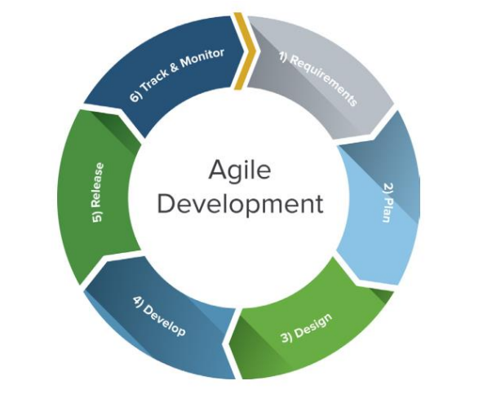

**Figure 1.1 Agile Development Cycle**

The agile development cycle contains 6 phrase which is requirement analysis, planning, design, implementation or development, testing, and deployment.

**Requirement analysis**

At this stage, we will review existing web music players on the market. After the review, we will find out what current users need and idea to improve the existing music players and collect their comments and suggestions for further analysis.

**Planning**

In the planning stage, we should first try to explore out the features that the music player can have. Next, we will eliminate the features that users feel no really useful or low cost-effective. Finally, each feature is prioritized and assigned to an iteration. Design The design stage is prepared according to the requirements of users. Since there are many details and problems encountered during development to be considered for each feature. Therefore, we will discuss and formulate solutions and test strategies to verify the product at this stage.

**Implementation or Development**

During the development phase, we will iteratively implement each of the features listed during the planning phase. At this stage, there will be many setbacks and obstacle, so the team needs to constantly overcome these obstacles. Moreover, we will prioritize the most important features and need to make intelligent trade-offs between the depth of completeness of a single feature and the breadth of implementation of multiple features.

**Testing**

In this stage, we will test the performance of each feature in order to check whether it meets the requirements of users. For example, we will test whether the application can be properly installed and run on a real device, and check whether any errors occur in the running process and each feature is up to standard.

**Deployment**

In this final phase, we will begin to deliver this application to the customer. For instance, we will upload this MP3 music player application in the Google Play Store, or posting download links on Utar Confession which is on Facebook in order to allow UTAR students to use it. In addition, we will anticipate that users will encounter unpredictable problems when using the player in this process, so we will solve these problems in a future version.

**Chapter 2 BACKGROUND AND LITERATURE SURVEY**

**2.1 Existing system**

**2.2.1 Review on Spotify music**

Spotify is a free music player that can play all music on YouTube, support background playing music, and download the song into local storage for free. Its music library is extremely powerful that covers almost all songs, such as English, Chinese, Cantonese, Japanese and even Korean songs. It performs extremely well in terms of functionality and interaction between users and application.

The homepage of Spotify is ‘Discover’, in which random lists and popularity rankings of various music themes are provided such as rank, latest songs, and weekly. When users feel confused in selecting songs or tired of listening to classic songs, this feature allows users to directly click, listen to the latest music.

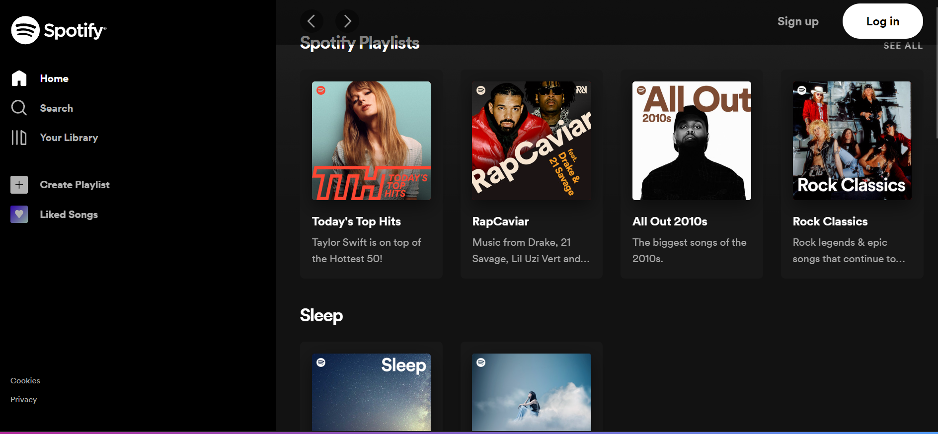

**Figure 2.1 Spotify UI**

Furthermore, the search page of Spotify supports searching according to the singer, song name, album, and others, enabling users to quickly find favourite music songs. The search page also has popular search keywords and recent search history records, make search feature more user-friendly and easier.

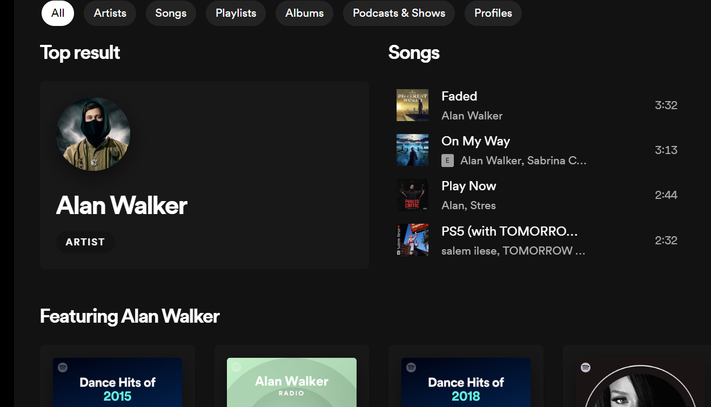

**Figure 2.2 Spotify ui**

In the playback control interface, the top is music video playback. However, it is not supported by playing the music only, but there is a "Save traffic" on the top right. Below is the playlist of songs, if users prefer to the music, it is allowing to download the song by clicking "Download" button which next to the song title and selecting the file format. There are two formats can be chosen, which are MP3 and MP4. The downloaded MP4 files can be viewed offline.

There is an option which is the 'Add' button next to the song title, it represents to add the song to the playlist created by users. In "My Music" page, users can create their own music world by adding favourite songs into the playlist. All playlists are free to create and unlimited in number. In the meantime, users can decide on the cover page of the playlist by placing the song on the first ordering. Unfortunately, local songs in the storage of the phone cannot be added in the playlist, only songs downloaded from Spotify can be added.

**2.1.2 Review on Saavan Music**

Saavan music is a music player application owned by Hangzhou Alibaba Music Technology Co., Ltd. Saavan's design team is a group of people who love music and life. They started the development of Saavan music in the year 2006. In the early days, Saavan music was also called "JIOSAAVAN",. So far, Saavan music's efforts and professionalism have been recognized by many users, with 14.4 million active users in India every month. In addition, Saavan has also been committed to supporting original music for a long time. It takes the lead in launching original music supporting projects in India to explore and cultivate a new generation of artists for the music industry.

sic main page is to adopt the frameless and blank leaving design looks very comfortable.

However, due to the amount of information on likes and comments in the music community, a large number of blank-leaving design make the visual experience lack hierarchy and increase reading difficulties. Therefore, the divider line can be used in the music community to divide each user's messages. The dividing line represents a wall, which can be used to categorize disorganized information.

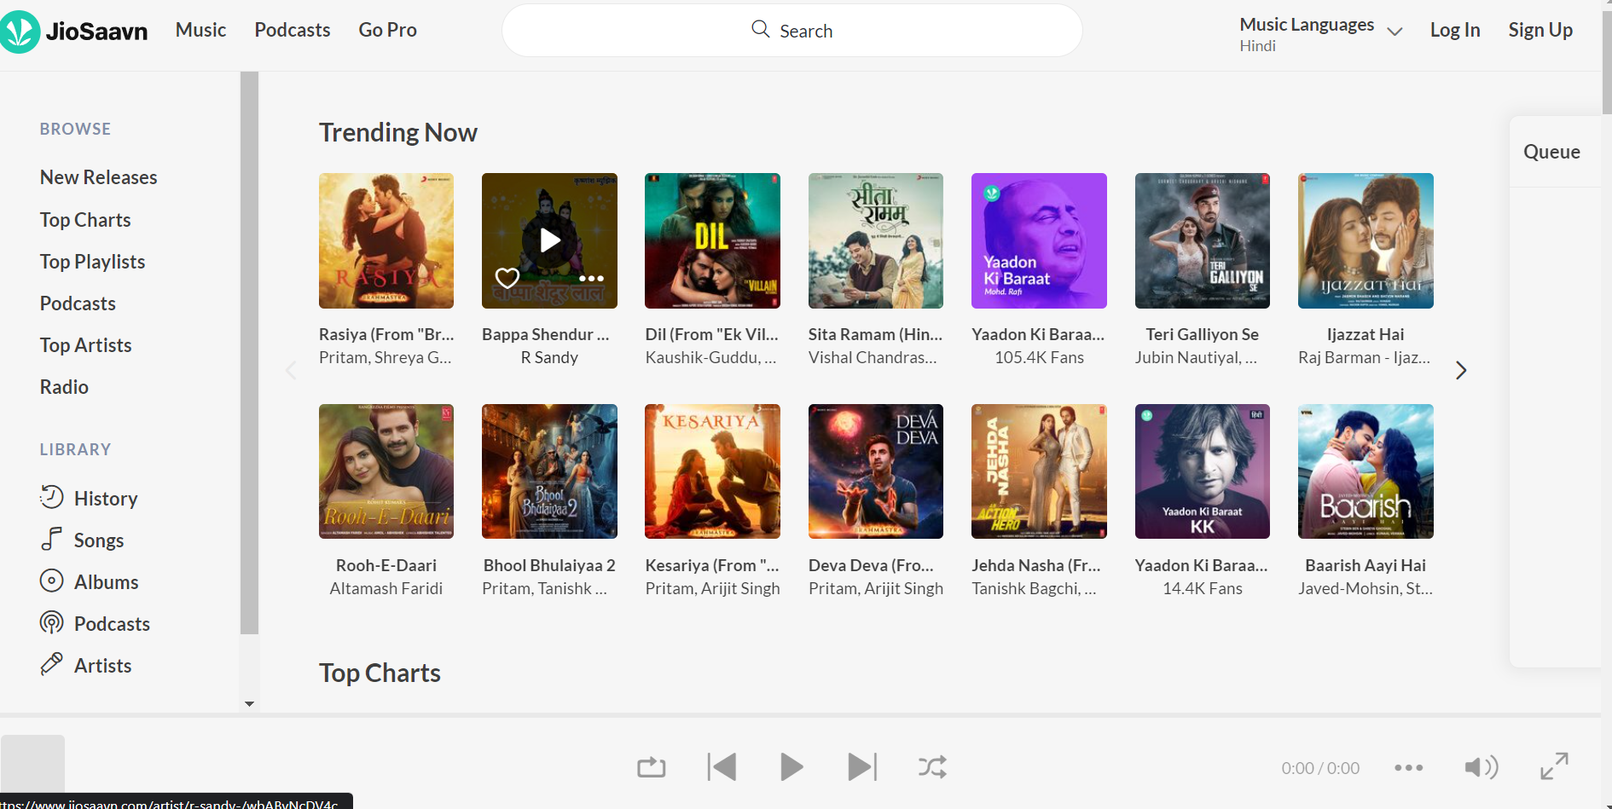

**Figure 2.3 Saavan ui**

Four categories are found at the top of Saavan music main page, which are a library, discover, video and news. The different genres in a music library are categorized clearly, which makes people feel the professionalism and dedication of Saavan music team. It's almost like an encyclopaedia of the music genre, there are even several subcategories for each genre.

In addition, the discover page is to recommend various playlists to users by system. In the discovery page, the users can be swipe down indefinitely, different content will be automatically loaded and refreshed, which makes users have an endless sense of freshness in the music world.

However, as we see that due to the recommended content occupies too much space of screen so that users need to constantly swipe down to see more content, which makes filtering content less efficient. Hence, it can be improved by narrowing the space of each content. For example, there is around two or three new contents on a discovery page, so users can explore and access more music libraries, and can find what they want more quickly and conveniently

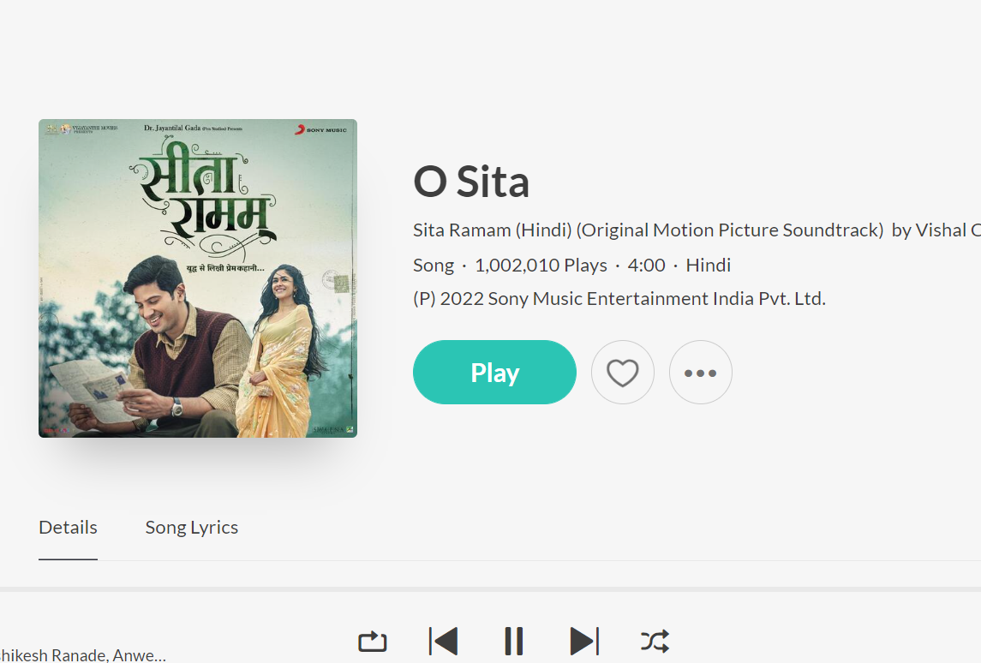

Moreover. night mode is about the background colour of the music player interface will be changed to black, which is to meet the bad habit of modern people still playing mobile phone after turning off the light, so that when they use the music player in the dark environment, the light in the phone will not be so dazzling.

Summary, Saavan music compared to other music apps, it is more emphasized on the experience of listening to music, like a specially prepared for those who love music. It has a neat user interface, no additional unnecessary features due to it is a music player, so listening to music is the most main features

**2.1.3 Review on SoundCloud Music**

SoundCloud, owned by Tencent Mobility Limited is a streaming music service APP launched in 2015. Its main markets are Hong Kong, Malaysia, Indonesia, and Thailand, and it is the most downloads music player application across Google Play and IOS (Mulia, 2018). In addition to the existing multiple features, SoundCloud continuously listens to the voice and feedback of customers and launches new features to satisfy users. The SoundCloud user interface is simple and grouped into three groups which is me, discovery and live. On top of each interface, there will be a search bar, allowing users to search favorite songs at any time, has a good interactive.

In the "ME”, users can create a new playlist to manage played and downloaded songs. In addition, SoundCloud will automatically import song on the user's device.

Moreover, one of SoundCloud's features, "My Karaoke”, is a boon for karaoke fans. My karaoke features are very comprehensive after users record their nice songs; they are allowed to preview just recorded songs before saving. Also, users are allowed to edit the recorded songs such as sound offset, vocal or music volume and add effects.

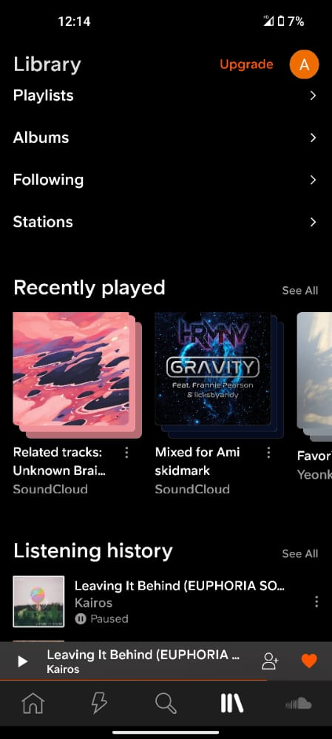

Next, users can search for their favourite songs through various categories on the discovery page. In the artists and playlists under the discovery page, the categories are detailed classification and the layout is neat, just like users stay in a real karaoke room, allowing users to immerse themselves in the music world.

In the radio page, there are around more than 50 theme stations classified according to different song styles, and users can play songs by only one click. Also, the live page is about some artist' interview, live, and their music video.

In addition, the music playback control page with basic functions that users generally need. The layout of the interface is easy to understand and the operation is very simple, which can be mastered immediately after the first use. From show that users can share their favorite songs with their friends at any time. But it has a flaw that users can't rewind and fast-forward freely when playing popular songs because of it is a VIP's privilege.

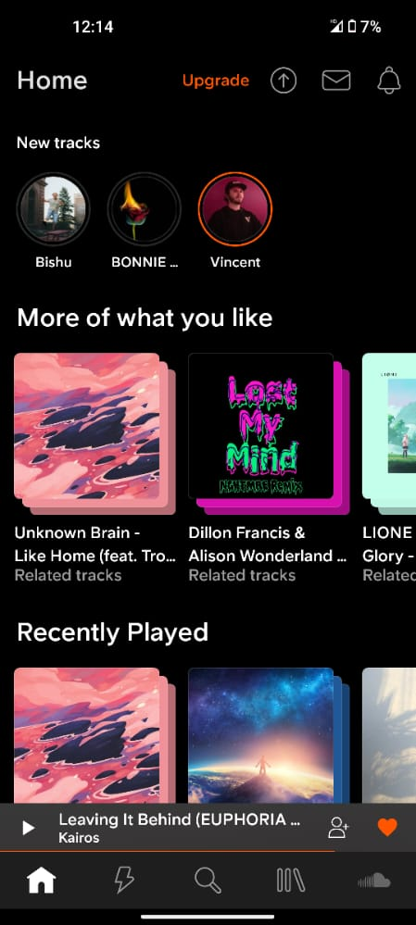

The biggest drawback of SoundCloud is that many operations require to become VIP, such as downloading or listening to most of the songs. With so many apps out there, that offer free downloads or listen to songs that could drive some users away. So, SoundCloud can introduce some tasks or mission features to relieve the limit once they have done the tasks so that allows users to gain VIP's privileges within a limited time.

To conclude, SoundCloud is comfortable to use, friendly in music classification, and it also allows users to change SoundCloud interface skin freely. It's a great paid music player

## 2.2 Software Requirement Specifications

Functional Requirements:

* Able to import the web format files on the device into the music player
* to play audio files smoothly
* Able to download or listen to the song by searching for the name of the song, album, or artist
* World charts
* top charts
* top artists
* Around you
* Songs in playlists can be quickly searched and filtered through the alphabet and search bar

Non-functional Requirements:

* Simplify user interface
* Optimize the design to display the information in a better ways

## 2.3 FeasibilityStudy

### **2.3.1 Strength and Weaknesses of previous works**

|  |  |  |
| --- | --- | --- |
| **Application** | **Strength** | **Weaknesses** |
| Spotify Music | Able to download music on YouTube | Lack of hierarchy in some user interface |
| Saavan Music | Lightweight application and emphasize the experience of listening to music | Annoying ads keep pop up during using |
| SoundCloud | With useful features such as My Karaoke | A large number of features require  VIP privileges |

**Table 2.1 Strength and Weaknesses of reviewed application**

## 2.4 *Innovativeness and Usefulness*

The main highlight of the project is to make the proposed application become a high learnability application without too many complex features, enhance the interaction between the user and the media control so that the user can have a better experience to achieve real pressure relief. It is worth mentioning that the music player has the audio trim function. Users can trim the best parts of the audio by setting the starting and ending points of the audio, which can be used as a ringtone. In addition, the ability to enhance the interaction between users and media control is that the application can skip songs by shaking the phone under the lock screen status of the phone. Also, the application utilizes the gesture controls to get rid of its reliance on touch buttons. For example, a song can be switched when the user slides left or right on the music playing interface.

## 2.5 Modification and improvement over the existing implementation

When the user starts the application, they can select two types of the main action of the application. The main action is divided into the music player and mp3 cutter. The first case is a music player, where users can select a song they want to listen to under the "My music" fragment and click it to play. In the music playing interface, users have a variety of options for action which are playing as driver mode, Around you, Updated Discover page, media control with the icon button. The second case is an mp3 cutter. After the user selects the song he or shea sort the genres, the application will start to trim the music and save it to the mobile device. At this point, the application will ask the user if they want to set the trimmed audio to ringtone and then finish the action. After the completion of the action, the user can choose whether to exit the application or not, if "no" back to select action interface, if "yes" terminate the application

**Chapter 3 PROCESS MODEL**

**3.1 Use Case Model**

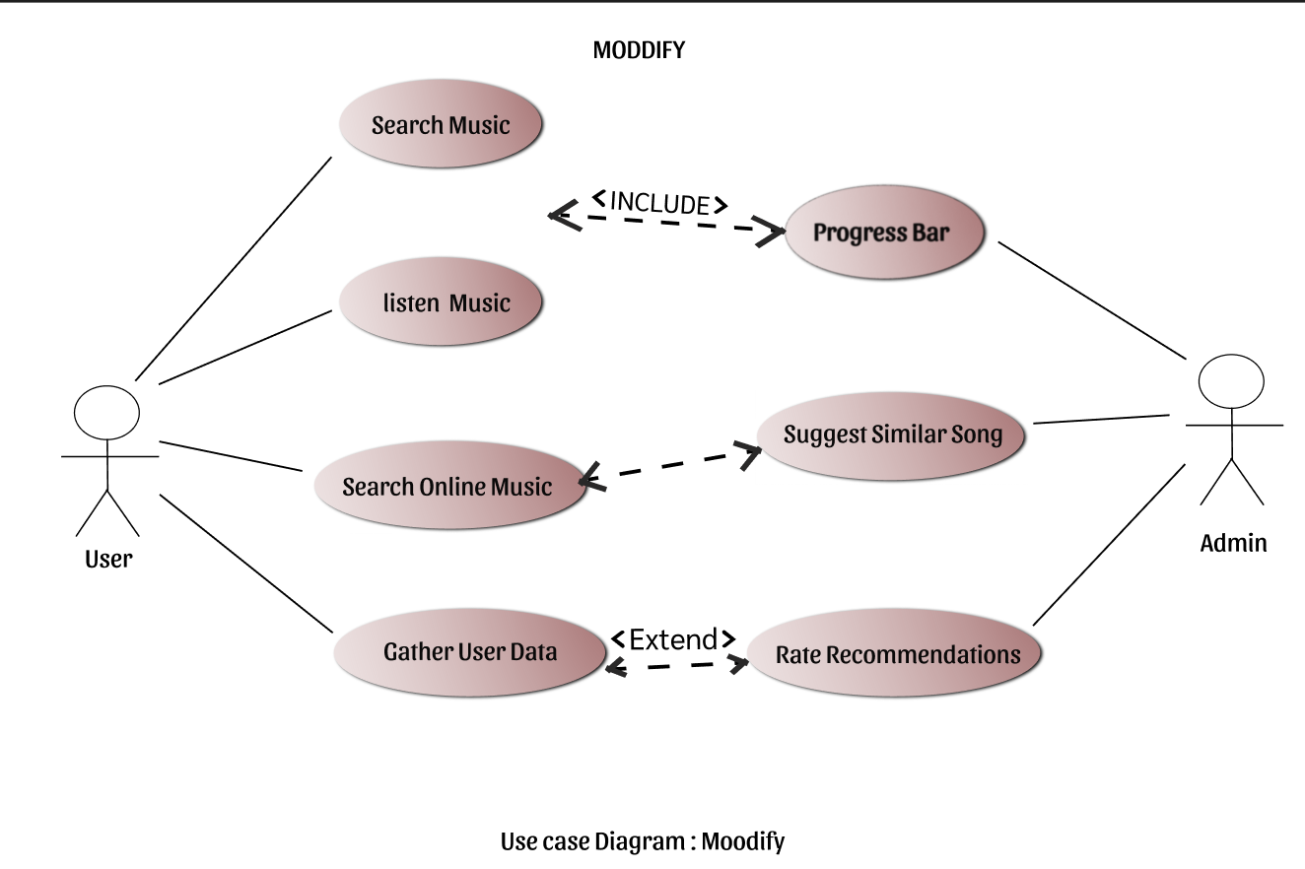

**Figure 3.1 Use case diagram of Moodify**

|  |  |
| --- | --- |
| Use case name: Listen to music | ID: UC001 |
| Actor: User | |
| Description: User able listen to music on this application | |
| Trigger:   1. User select any song from the playlist 2. User click the play button to start playing the music | |
| Precondition:   1. The user should import the song from their mobile device into the music player 2. The user should add the song into a playlist by search music online feature | |
| Normal flow of events:   1. User select a song from the playlist 2. The song playing until the end | |
| Alternate / Exceptional flows:  1a. The application will display a message "No local music" if the playlist does not have any song | |

**Table 3.1 Use Case Description of Listen to music**

|  |  |
| --- | --- |
| 1Use case name: Progress bar | ID: UC002 |
| Actor: User | |
| Description: The progress bar shows the progress of the song | |
| Trigger:  1. The progress bar becomes active when the user starts playing the song | |
| Precondition:  1. The song must in playing status | |
|  | |
| Normal flow of events:   1. Song is playing 2. The progress bar will show the duration of the song 3. The progress bar will be finished if the song is finished playing | |
| Alternate / Exceptional flows:  1a. The progress bar will reset if user play other song  2a. If the user drags the progress bar to left or right, the song's progress will changes 3a. The progress bar will reset if finished playing | |

**Table 3.2 Use Case Description of Progress bar**

|  |  |
| --- | --- |
| Use case name: Driver mode | ID: UC003 |
| Actor: User | |

**Table 3.3 Use Case Description of Search music online**

**3.2 Activity Diagram**

**3.2.1 Listen to music**

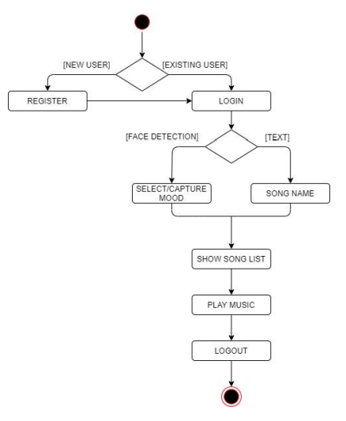

**Figure 3.2 Activity Diagram for User to Listen to Music**

The user starts the application and then it will go to the home page which is the "My music" page. The application will read the device's local songs and generate a playlist. After that, the user selects the song and plays it, the page will jump into the playing music interface, where the user is allowed to control the music. Playing modes are allowed to control music play orders which are shuffle playback, single cycle, and normal playback. Moreover, the user can also skip to the next song, back to the previous song and play or pause the current music to control music. Lastly, the user can enable the driver mode to play the song.

**3.3 ER Diagram**

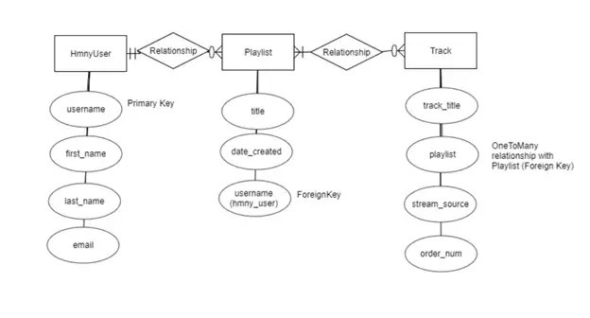 **Figure 3.3 ER Digram for User to Listen to Music**

**3.4 System Model Diagram**

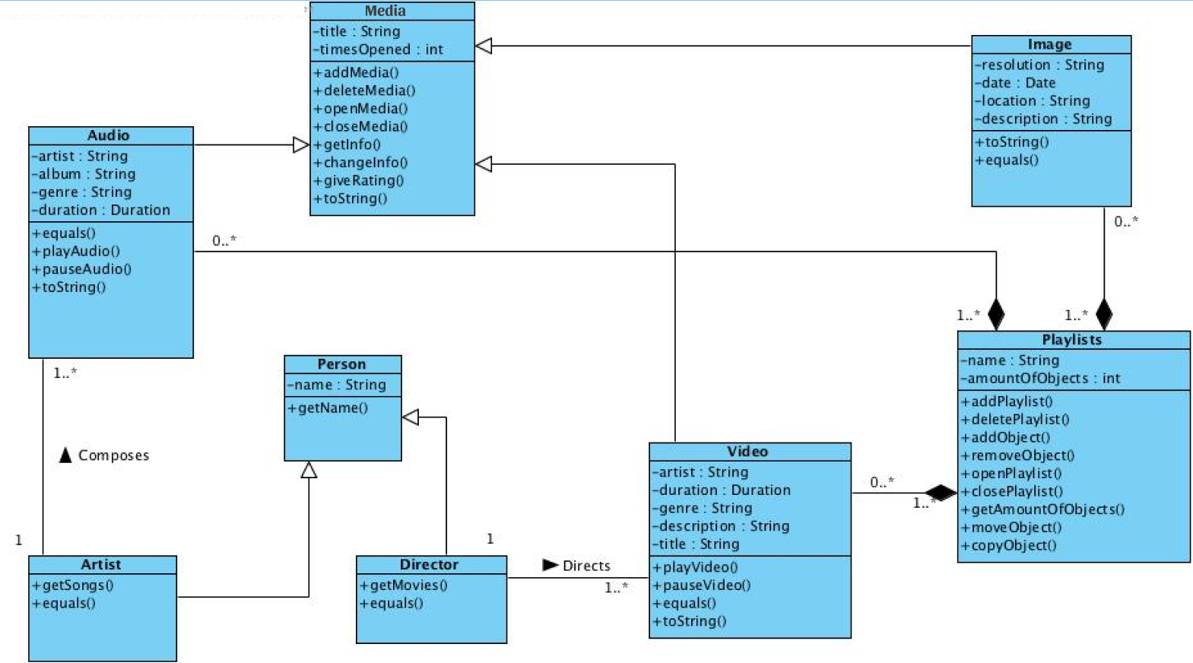

**Figure 3.4 System Model Digram for User to Listen to Music**

**3.5 Data flow Diagram**

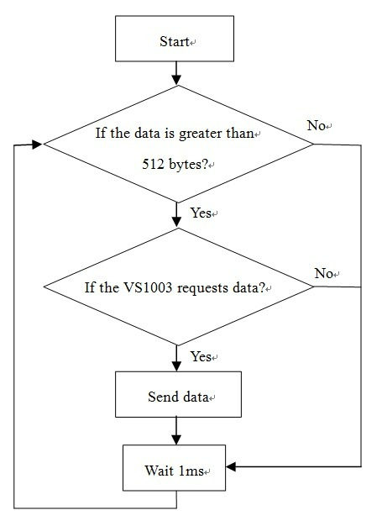

**Figure 3.5 Data Flow Digram for User to Listen to Music**

**3.6 Algorithm**

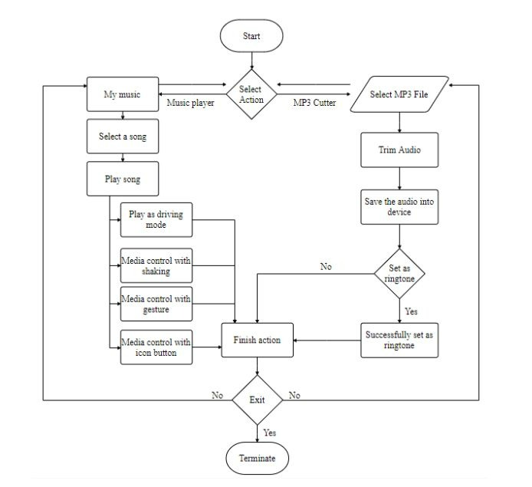

**Figure 3.6 Algorithm for User to Listen to Music**

**3.7 Around you**

Accessibility to stream the music that is popular and played many times around your geo location area. Current music recommender systems rely on techniques like collaborative filtering on user-provided information in order to generate relevant recommendations based upon users' music collections or listening habits.We assume that music is naturally diffused through the social network of its listeners, and that we can propagate automatic recommendations in the same way thro-ugh the network. In order to test this statement, we devel-oped a music recommender application called Starnet on a Social Networking Service.

**3.8 Discover**

In order to categorize music discovery in general, various song make the distinction between active and passive music discovery , This fact has been exploited, among others, where a social approach for music recommendation is presented. It is based on the assumption that friendship relations are similar to those are indicative of similar music tastes. one’s discovered music, more so than freely chosen songs, may be more widely representative of musical preferences, as it encompasses music (and musical features) beyond the scope of what a user could have articulated in advance that he wanted to hear-and possibly across a broader range of musical genres .

**3.9 Change Theme**

There are five types of theme colours for users to select. After the user changes the theme colour, the theme on "Spotify" and "" will be updated to the selected colour,

Once you pick your Spotify theme colours, you can update Spotify to import thetheme. First, you need to specify your theme in the configuration file.

You might also note the "colour Theme" option, beneath "current theme." If you create multiple color schemes within a single colour in file, this is where you type the colour

**Chapter 5 TECHNOLOGY AND TOOLS USED**

**5.1 Technology used**

1.Node Js

2.Express Js

3.React

4.Javascript

5.Rapid API

6.Netlify (For Hosting)

**5.2 Front-end Tools**

**5.2.1.React**

React (also known as React.js or ReactJS) is a free and open-source front-end JavaScript library for building user interfaces based on UI components. It is maintained by Meta (formerly Facebook) and a community of individual developers and companies. React can be used as a base in the development of single-page, mobile, or server-rendered applications with frameworks like Next.js. However, React is only concerned with state management and rendering that state to the DOM, so creating React applications usually requires the use of additional libraries for routing, as well as certain client-side functionality.

**5.2.2.Javascript**

JavaScript (js) is a light-weight object-oriented programming language which is used by several websites for scripting the webpages. It is an interpreted, full-fledged programming language that enables dynamic interactivity on websites when applied to an HTML document. It was introduced in the year 1995 for adding programs to the webpages in the Netscape Navigator browser. Since then, it has been adopted by all other graphical web browsers. With JavaScript, users can build modern web applications to interact directly without reloading the page every time. The traditional website uses js to provide several forms of interactivity and simplicity.

Although, JavaScript has no connectivity with Java programming language. The name was suggested and provided in the times when Java was gaining popularity in the market. In addition to web browsers, databases such as CouchDB and MongoDB uses JavaScript as their scripting and query language.

**5.2.3.Netlify (For Hosting)**

Netlify is a remote-first cloud computing company that offers a development platform that includes build, deploy, and serverless backend services for web applications and dynamic websites. The platform is built on open web standards, making it possible to integrate build tools, web frameworks, APIs, and various web technologies into a unified developer workflow.

**5.3 Back-end Tools**

**5.3.1.Node Js**

Node.js is an open-source, cross-platform JavaScript runtime environment and library for running web applications outside the client's browser. Ryan Dahl developed it in 2009, and its latest iteration, version 15.14, was released in April 2021. Developers use Node.js to create server-side web applications, and it is perfect for data-intensive applications since it uses an asynchronous, event-driven model.

There are many reasons for which we prefer using NodeJs for the server side of our application, some of them are discussed in the following:

* NodeJs is built on Google Chrome’s V8 engine, and for this reason its execution time is very fast and it runs very quickly.
* There are more than 50,000 bundles available in the Node Package Manager and for that reason developers can import any of the packages any time according to their needed functionality for which a lot of time is saved.
* As NodeJs do not need to wait for an API to return data , so for building real time and data intensive web applications, it is very useful. It is totally asynchronous in nature that means it is totally non-blocking.
* The loading time for an audio or video is reduced by NodeJs because there is better synchronization of the code between the client and server for having the same code base.
* As NodeJs is open-source and it is nothing but a JavaScript framework , so for the developers who are already used to JavaScript, for them starting developing their projects with NodeJs is very easy.

**5.3.2.Express Js**

Express is a minimal and flexible Node.js web application framework that provides a robust set of features to develop web and mobile applications. It facilitates the rapid development of Node based Web applications. Following are some of the core features of Express framework −

* Allows to set up middlewares to respond to HTTP Requests.
* Defines a routing table which is used to perform different actions based on HTTP Method and URL.
* Allows to dynamically render HTML Pages based on passing arguments to templates.

**5.3.3. Rapid API**

RapidAPI, the world's largest API hub, is used by over three million developers to find, test, and connect to thousands of APIs — all with a single API key and dashboard.

Find the APIs that you need for your project, embed the API into your app, and track usage of all your APIs through a single dashboard. If you create an API, use RapidAPI to make it available to over three million developers already using the RapidAPI Hub.

**5.3.4 Operating System**

An operating system (OS) is the program that, after being initially loaded into the computer by a boot program, manages all of the other application programs in a computer. The application programs make use of the operating system by making requests for services through a defined application program interface (API). In addition, users can interact directly with the operating system through a user interface, such as a command-line interface (CLI) or a graphical UI (GUI).

**→** Support All window version above window XP.

**Chapter 6 *HARDWARE REQUIREMENT***

**6.1 Software Requirement**

1. Android Studio

2. Java SE 8

3. Visual Paradigm

**6.2 Hardware Requirement**

**1. Laptop**

- Processor: Intel(R) Core(TM) i7-4500U CPU @ 1.80GHz 2.40 GHz

- RAM: 12.00 GB

- Graphic Card: NVIDIA GeForce GT 740M

- Hard Disk storage: 1TB - Operating System: Windows 10 Professional Edition

**2. Smartphone device**

- Processor make: Qualcomm Snapdragon 652 (MSM8976)

- RAM: 4.0 GB

- Phone Storage: 64 GB

- Operating System: Android version 5.1.1 (Lollipop)

**Chapter 7 CODING**

**7.1 Implementation**

The main aim of this project is to play online music and very easily with free of cost. The project "Spotify" after being tested and was found to overcoming all the problems of the existing music player. This music player is found to be error free and ready for implementation.

The proposed web application completed the debugging task during the testing phase, then it should enter the deployment phase. In the deployment phase, the developer needs to host the web application on server which is generate as “Moodify Link”, users can access this web application through "modify link”.

However, due to the number of users are limit so far and the proposed web application is not in the final public version, there are still many modules that should be improved and updated.

Therefore, it will be uploaded to the relevant platform to promote to users after the final public version is released.

Below are the steps to describe how a new user will execute the proposed application:

1.The user first execute the application, he or she needs to give the proposed application the permissions it needs to read local songs on the phone and load them into the song playlist.

2.Users can play a song by clicking on one of the songs on the playlist.

3.In the song playback interface, the user is allowed to drag the progress bar, as well as perform media control through the icon buttons, gesture and shaking the phone.

4. Users can make their own playlist according to their music taste.

**Chapter 8 TESTING**

Unit test 1: Music Player

Test Objective: To ensure that the song selected by the user can be played normally, the selected song information is displayed normally, and the song playlist can be import and show properly

|  |  |  |
| --- | --- | --- |
| **Input** | **Expected Output** | **Actual Output** |
| Click "worldwide" in the category | The song playlist under world chart category was successfully read and contains English songs and other songs | Pass |
| Click "pop" in the category | The song playlist under pop category was successfully read and contains English songs and other songs | Pass |
| Choose any song from the playlist | Enter the song playing interface, the song can be playing properly, and successfully display the selected song name, album name and artist name | Pass |
| Play any song and click the home button to make the app run in the background | Songs still playing in the background | Pass |

**Table 8-1 Unit Testing of Music Player Module**

Unit Testing 2: Media Icon Playback Control

Test Objective: To ensure that all playback control icon buttons under playing song interface can work and perform properly

|  |  |  |
| --- | --- | --- |
| **Input** | **Expected Output** | **Actual Output** |
| Click the song playback mode to switch to shuffle playback | When the current song finished playing, and it will randomly choose a song from the playlist to play, rather than playing the song in the order of the playlist | Pass |
| Click the song playback mode to switch to the single cycle | When the current song finished playing, just repeat the current song | Pass |
| Click the song playback mode to switch to normal playback | When the current song finished playing, play the song in the order of the playlist | Pass |
| Click the pause button | Stop play the song, the pause button is updated to the play button | Pass |
| Click the play button | Switch to the next song, the song name, album name, and artist name are also successfully updated to the next song's information | Pass |

**Table 8-2 Unit Testing of Media Icon Button Playback Control Module**

Unit Testing 3: Driver Mode

Test Objective: To ensure all button and song info under driver playing mode interface will be enlarged and can play the song properly.

|  |  |  |
| --- | --- | --- |
| **Input** | **Expected Output** | **Actual Output** |
| Click driver mode button in the song playing interface | Successfully switch to the driver mode interface, and successfully update the current song playing information | Pass |

**Table 8-3 Unit Testing of Driver Mode** **Module**

Unit Testing 4: Around you

Test Objective: To ensure the working of the recommendation of songs.

|  |  |  |
| --- | --- | --- |
| **Input** | **Expected Output** | **Actual Output** |
| Click Around you button in the song | Successfully switch to the around you page, and successfully update the current songs. | Pass |

**Table 8-4 Unit Testing of Around you** **Module**

**Chapter 9 Screen Layouts**

**9.1 On Desktop**

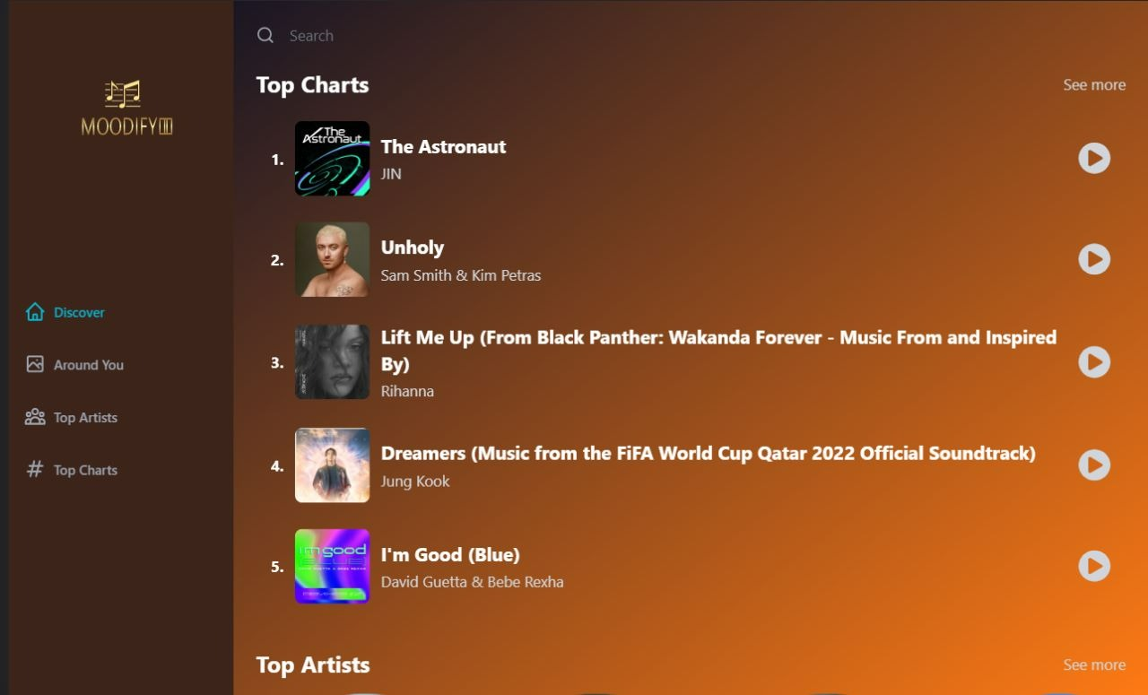

**Figure 9.1 UI on Desktop**

**9.2 On Tablet  
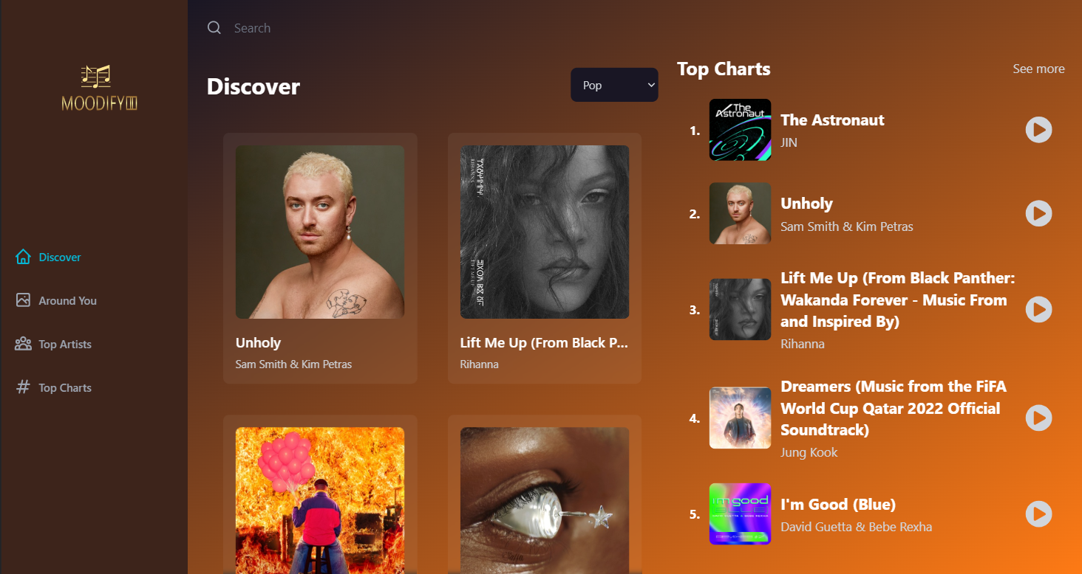**

**Figure 9.2 UI on Table**

**9.3 On Mobile**

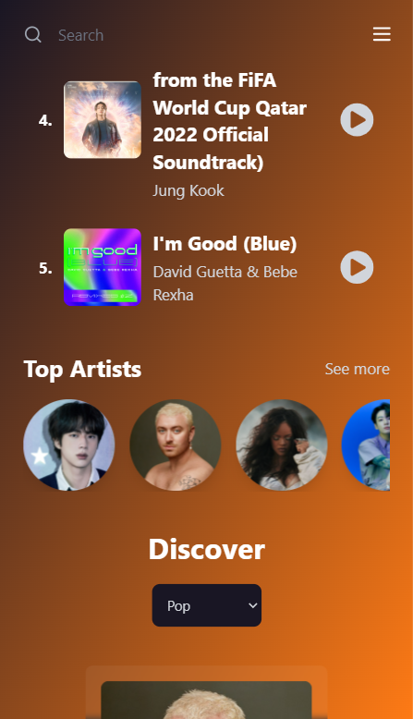

**Figure- 9.3 UI on Mobile**

**Chapter 10 Future Enhancement**

In addition, users can login, register and they can make their own music library and can add songs in their library. In future we will add one feature, if the user is going somewhere, then whatever songs and music is playing in the middle of the way, then this web application will recognise them and add those all songs to a separate playlist.

Users can connect with people listening to songs of their choice, and can chat with people.

**Chapter 11 Conclusion**

In a nutshell, when users hold the mentality of venting and relaxation to expect the music player to bring them relief pressure, in result the web application with a dazzling and complex interface, a variety of multifarious functions, from time-to-time prompt out of the advertising, as well as the function that requires be a member to use, which will only make users feel more depressed and feel the pressure. Sometimes user heard a small part of the particular song and music, and user wouldn't able to recognise the song, then this web application will scan those songs secretly and add them to a separate playlist.

In short, the proposed application will combine the strengths of most music players on the existing market and eliminate some unrealistic features, allowing users to focus on listening to music rather than store, communities or various VIP packages or features. The proposed MP3 music player will focus on improving the experience of users of the music player experience.

**Chapter 12 *Bibliography***

Guru99.com. (2019). Mobile App Performance Testing: CheckList, Tools (Andriod & iOS)

Joox.com. (2019). JOOX - Music Anytime Anywhere

Kr-asia.com. (2019). Spotify facing growth pains in Asia, where Tencent’s Joox is more popular

Mehul, R. (2018). Top Reasons Why Your Mobile App is Slow and How to Fix it.

Play.google.com.

Play.google.com

Sohail, Agile Project Management: Understanding and Benefits - DevCrew I/O.

BIS (Hons) Information Systems Engineering Faculty of Information and Communication Technology (Kampar Campus), UTAR. Scacca, S. (2020). When to Design with Gestures vs. Buttons

Xiami.com. (2019)

**CODE:**

**App:**

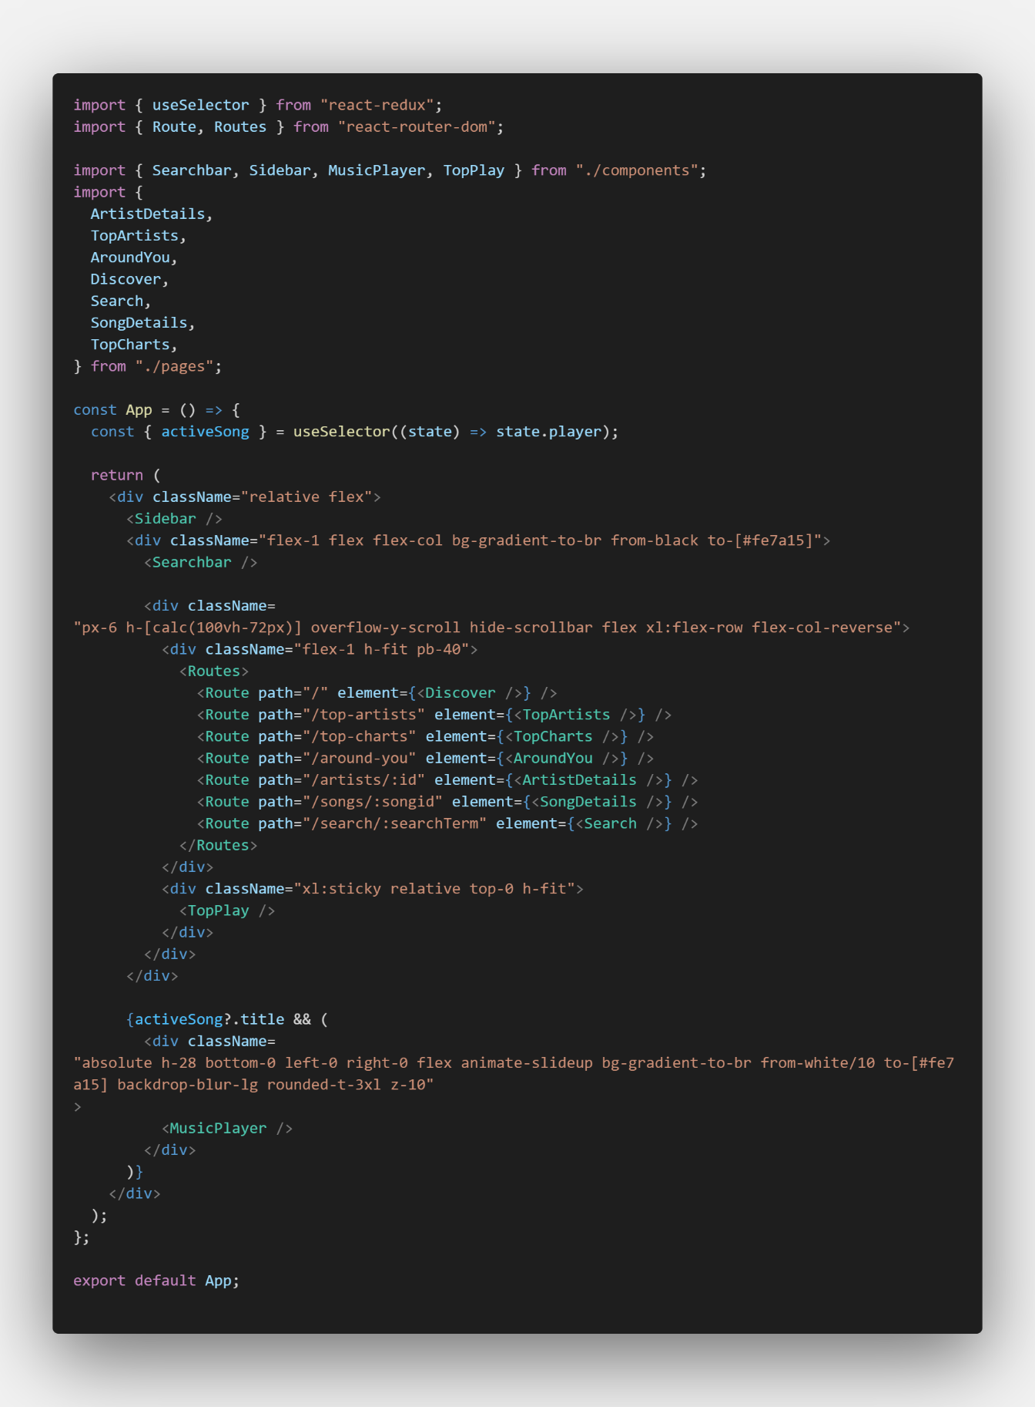

**Discover page:**

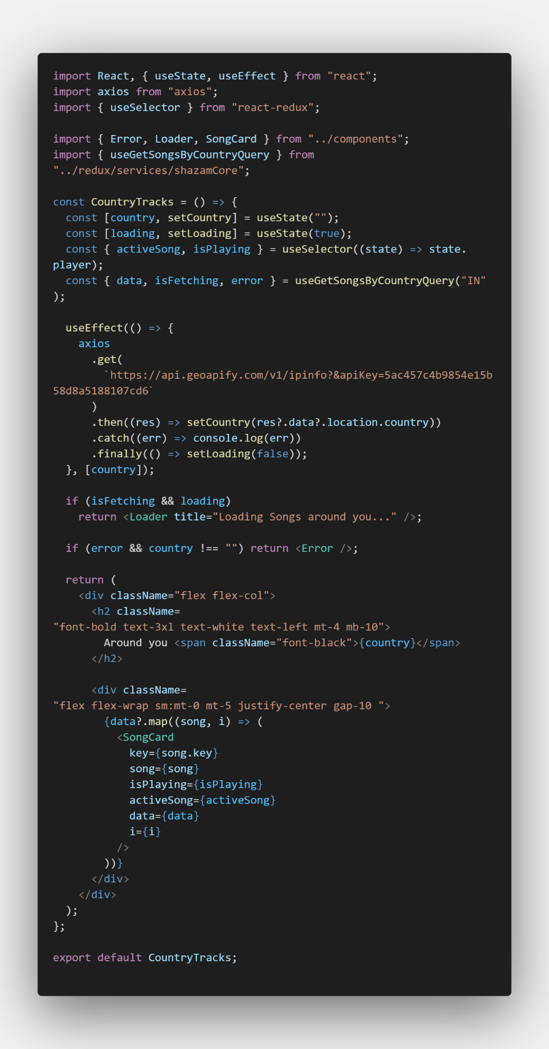

**Around You page:**

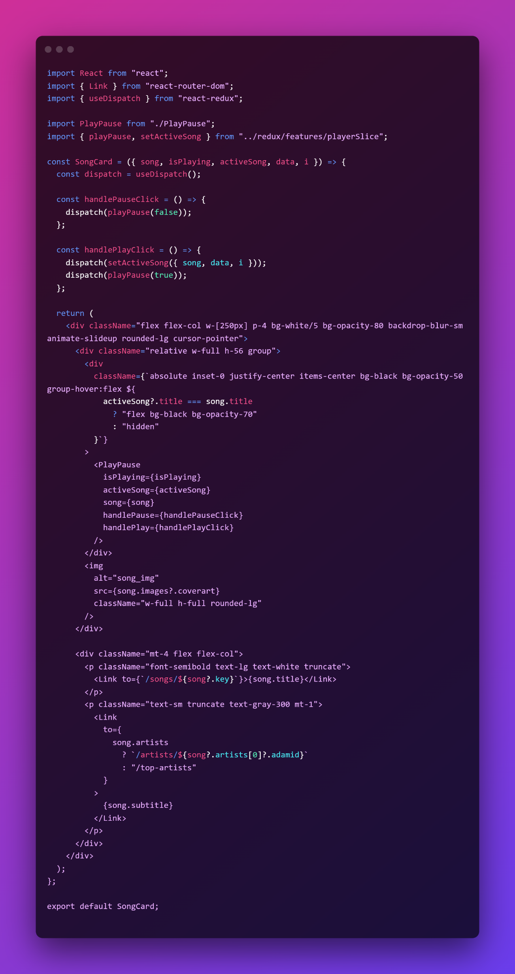

**Songs Detail page:**

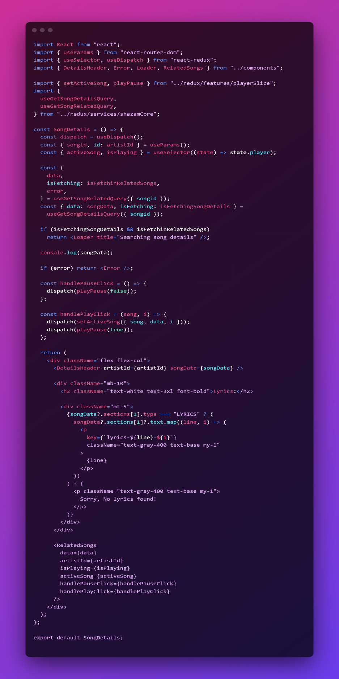

**Songcard Componenet:**

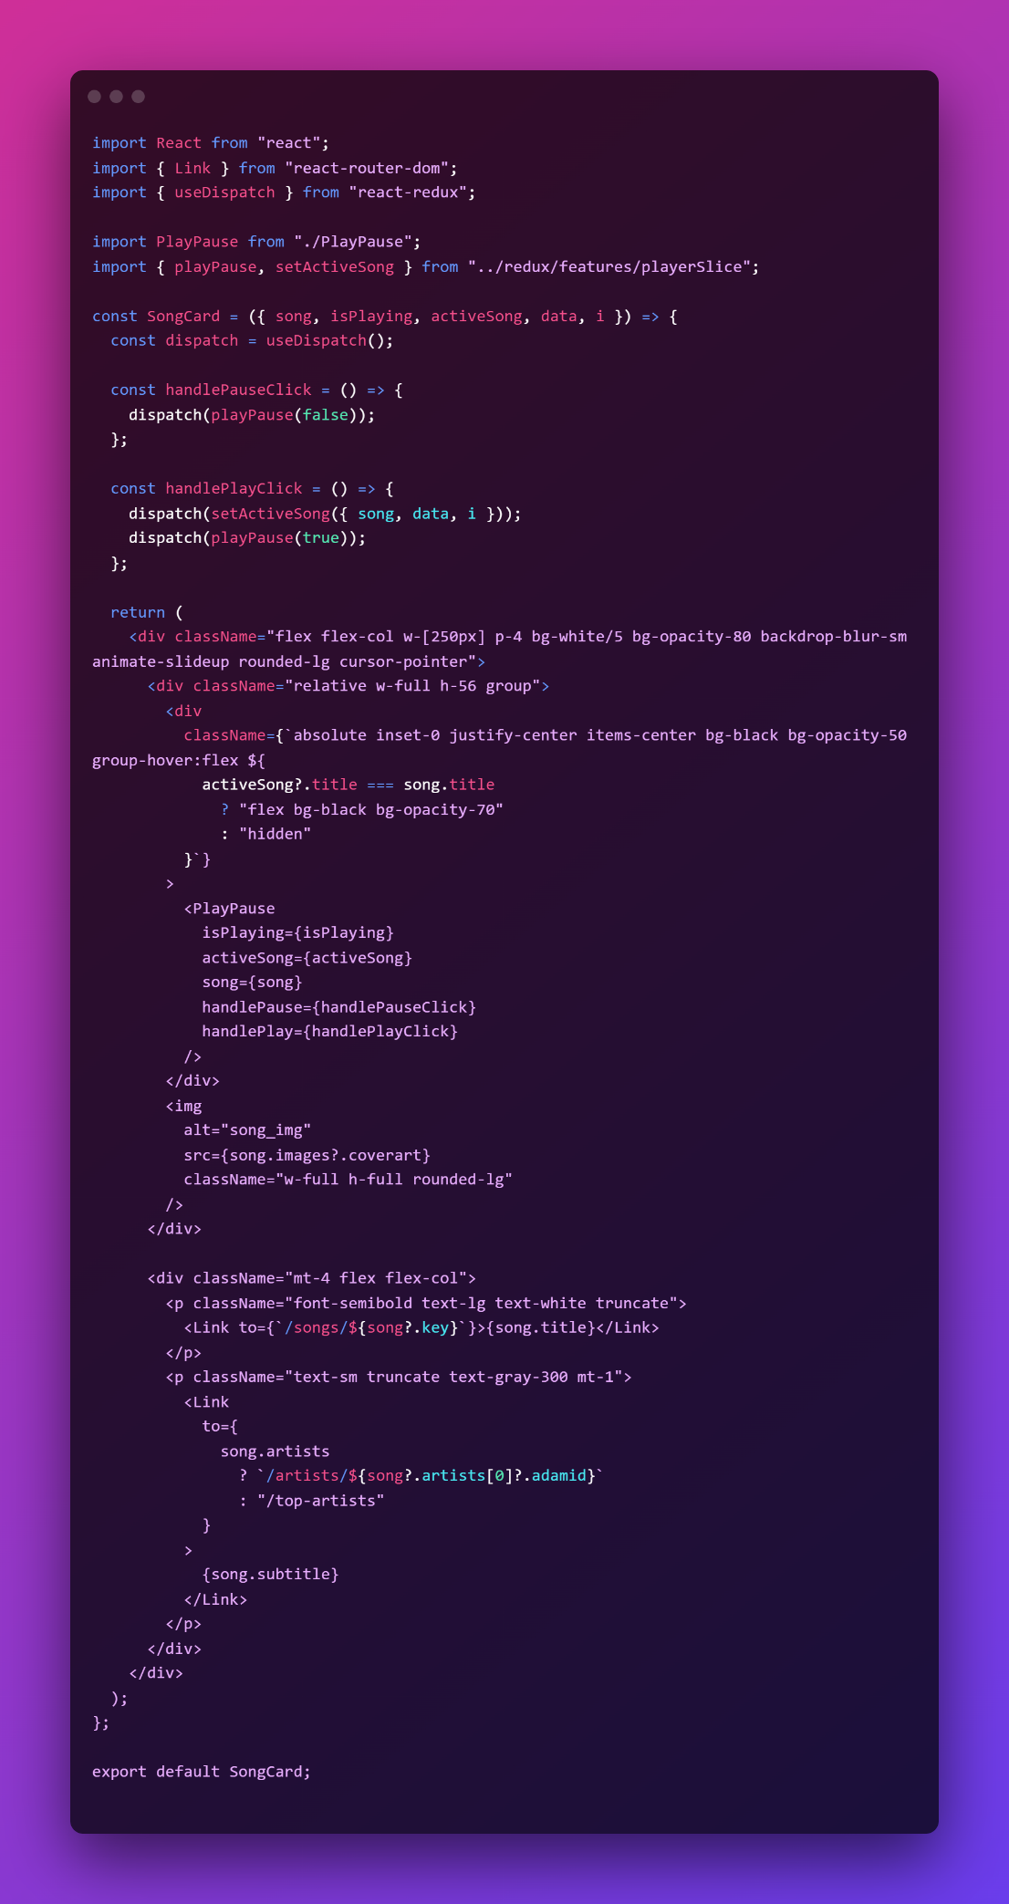

**SongBar Component:** 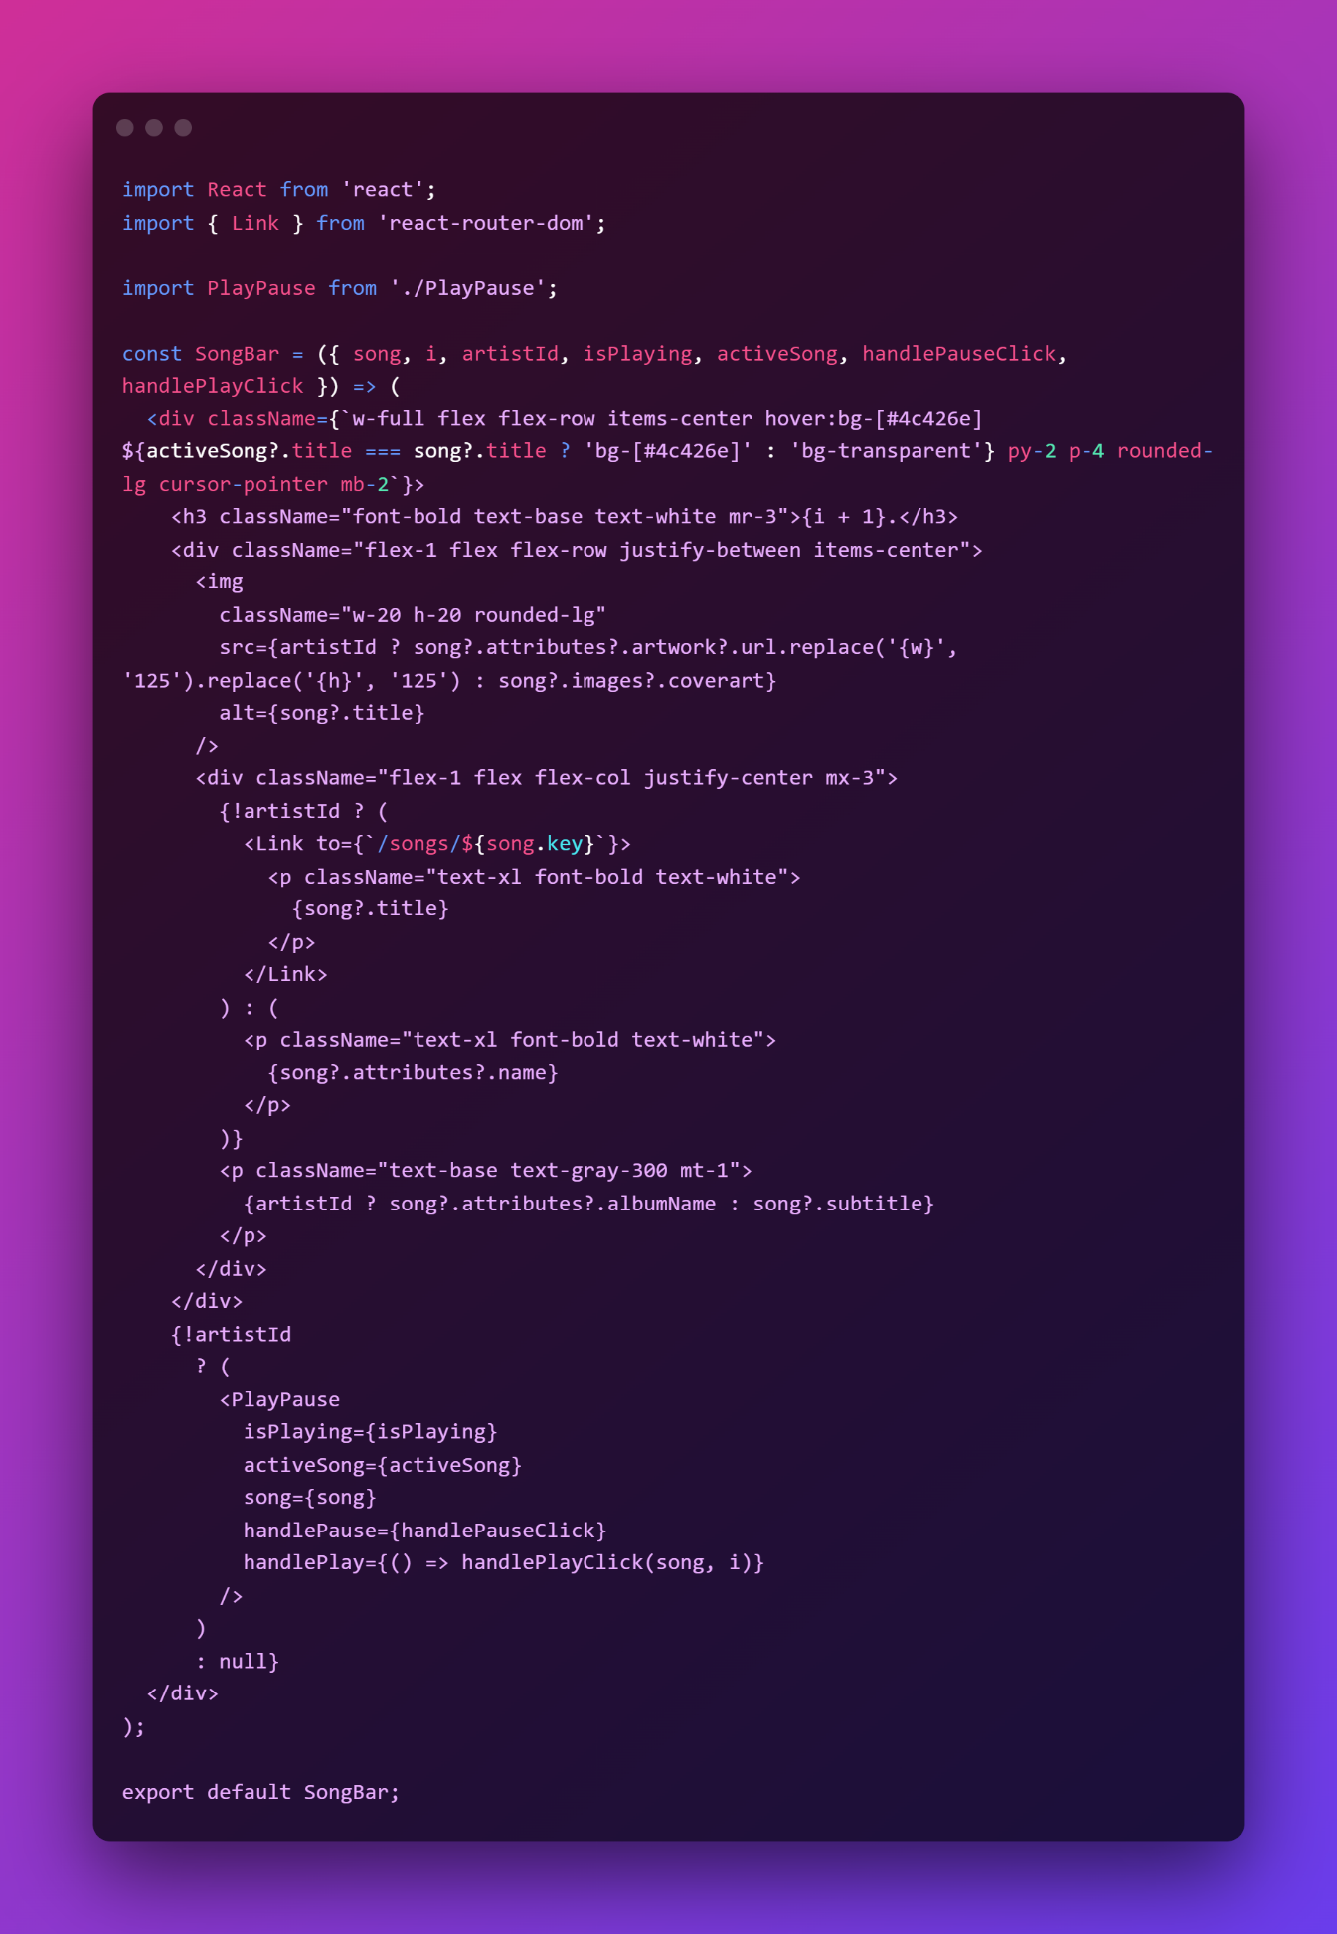

**Related Songs Component: 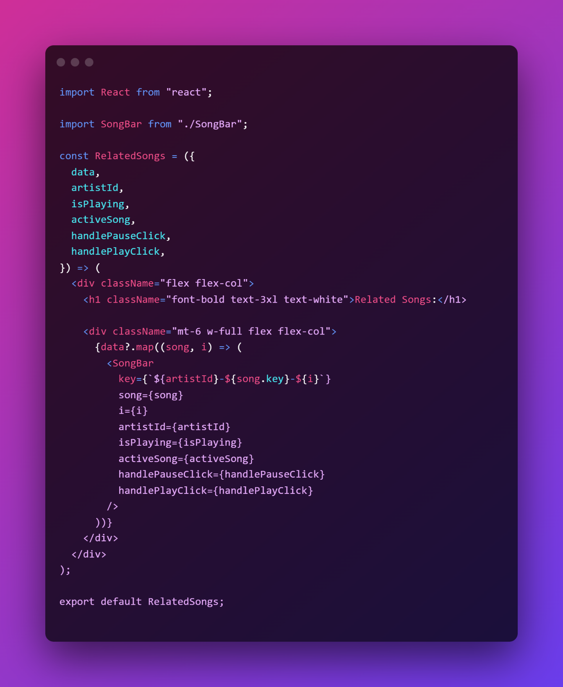 Detail Header Component:** 